|  |  |  |  |
| --- | --- | --- | --- |
| From: | Cody Lau | Date: | 03/09/2019 |
| To: | Giada Grandi | Ref: | PERF-MEMO-951 |
| cc: | James Harrison, | Issue: | 1 |
| Subject: | **Flow Data Analysis App** | | |
| Project Location: Q:\msd\Performance\MATLAB Projects\Fuel Flow Analysis App | | | |

# Introduction

Data from rig testing facilities are present to us in the .csv format, with 2 main sets of data from the ESR and Rig, each with a certain way of structuring the .csv files. For reporting or analysis use, it used to be done by way of manually opening all the .csv files into an Excel workbook and then creating a summary of average values from selected variables for each test point, then plotting the relevant graphs to demonstrate whatever the test was conducted for. This was very time consuming and tedious for our Engineers. Therefore an app was created in Matlab’s “appdesigner” to automate this process and save time. This document will describe step-by-step how to use this app and also provide troubleshooting and solutions/explanations to potential errors raised in the app.

# Capabilities

A quick summary of the functionalities of this app.

|  |
| --- |
| **Open Files** |
| ESR => only .csv or only blank extensions |
| RIG => in subfolders for each test point or all csv in 1 folder |
| RIG, merges multiple csv in each subfolder into 1 csv (same test point) |
| Checks correct file format => pop up error otherwise |
| Special sorting function for correct number order in file names |
| ↘ Follows natural number order (corrects . to _, space to _, zero to 0) (1.9, 1.10 instead of 1.10, 1.9) |
| **File Order** |
| Check file order in listbox to ensure correct order/aligned |
| Swap 2 test points' positions |
| Insert 1 or more test points above another item |
| Reorder all from scratch |
| Remove unwanted test points |
| Merge all selected test points' csv tables into a the first csv, affects actual files |
| **Save Summary** |
| Import summary created using this app, instead of opening files from scratch |
| Semi-manually select variables to include in summary (auto selects some using string search) |
| Save summary into user chosen location |
| ↘Summary of Average / Max / Min of each test point’s variables |
| ↘Pop up option to cancel or skip test point if error or missing variable |
| Prompt to reselect variables as listbox is refreshed for test point with diff. number of variables |
| Open Summary straight from the app |
| **Flow Calculation & Plot** |
| Plot chosen variable against time for single test point |
| User input Khl,Kcg,Kcl and dH if different from default |
| Plot Q^2 vs dP corrected for catenary for hose end / latch |
| Exclude / only include if P(HE) > 50 |
| Plot coupling loss against Q |
| Export flow calculation numbers into Excel (summary/copy/new) |
| ↘ avg. rho, Phead, all K, Q^2, dP, coupling loss, calculated P(HE), slope + Kloss etc. |
| Create graphs in excel format in summary (ESR & RIG Q^2 vs dP, coupling loss) |
| Highlight in summary Excel cells of Rig Hose End Pressure if > 50 psi |

# Supported File Formats

The app was coded to accommodate the formats as general as possible. Screenshots below show folder contents.

1. ‘Open ESR’ with ‘.csv’ will get all files in selected folder with .csv extension, ignoring all other types.

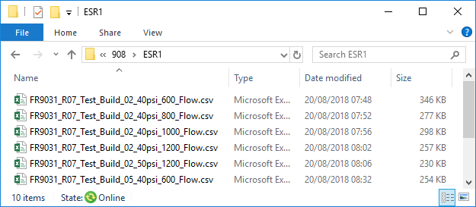

1. ‘Open ESR’ with ‘no extension’ will only get files in selected folder with empty extensions, ignoring others

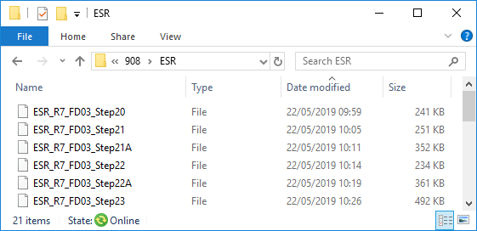

1. ‘Open RIG’ with ‘Subfolders’ will get .csv files in each subfolder of the folder selected, ignoring other types

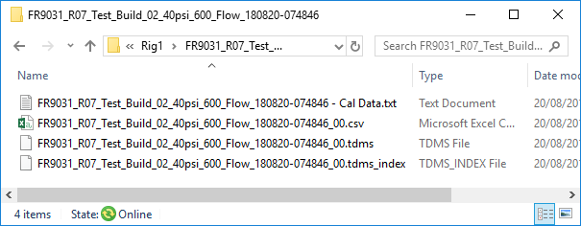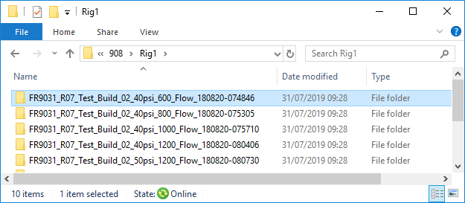

1. ‘Open RIG’ with ‘All in 1 folder’ is the same function as ‘Open ESR’ with ‘.csv’ (see 1. above)

# Instructions

Most of the buttons have tooltips to provide basic instructions on usage, but if not clear or if using 2017b version (no tooltips), then follow below’s more in depth instructions.

## Starting App

Double click on the .mlapp file for the relevant Matlab version (2018b/2017b). Alternatively, if App Designer is opened for editing (see 5. Troubleshooting), simply press the Run button at the top.

Alternate file location: S:\Cody Lau\Fuel Flow Analysis App

## Open Test Data

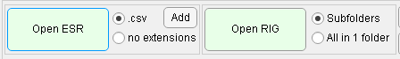Open ESR and Rig files using the appropriate options as described in 3. above, ‘Add’ is used if there’s a mix of .csv and no extension; it will add .csv extension to selected files.

## File Order

Select the Pod model and click on ‘File Order’ to check and correct order. (Important as ESR and Rig might not be aligned due to name formats) Other 3 buttons are for support/help.

## Re-order Files

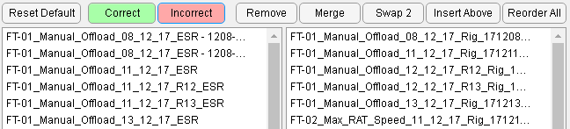Compare orders and press ‘Incorrect’ for options to reorder, ‘Correct’ to return to previous interface. Reorder options are described below.

1. **Remove**: Select test points to exclude and press button
2. **Merge**: Select all test points to combine and press button (warning: merges and deletes actual files)
3. **Swap** **2**: Select 2 test points and press button
4. **Insert** **Above**: Select all test points to move, press button, then select test point for those previously selected to be inserted above
5. **Reorder** **All**: Press button, then select test points one-by-one in order desired (updates in real time), press again to stop reordering
6. *Reset Default:* Refreshes both listboxES to original order, includes removed. Note: Disabled after merge

## Save Summary

Select the desired variables (‘Expand Columns’ to see make list box longer), then ‘Save Summary’

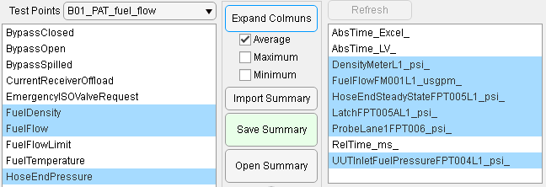

If the app detects different number of variables in a test point, it warns and allows new column selection.

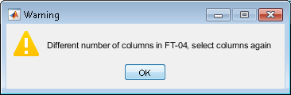 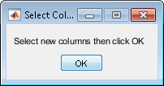

ONLY click on ‘OK’ after checking and reselecting same variables, if cannot remember, click ‘OK’ with wrong number of variables and previously selected variables will be displayed.

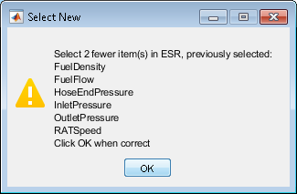

If the wrong number of variables are selected, a warning shows you what was previously selected. If variables missing from the listbox (impossible to continue), close warning window and new options allow you to cancel or skip.

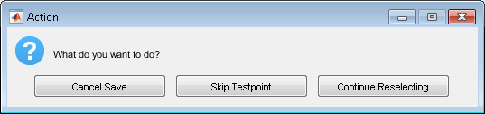

## Flow Equation Calculations

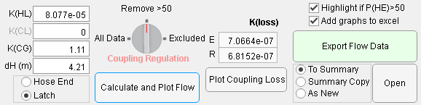Enter the correct constants and press ‘Calculate and Plot Flow’ to generate relevant flow equation numbers and plot GUI axes below this. ‘Export Flow Data’ to add the flow equation numbers to the Summary/as New in Excel with/without the ‘Add Graphs’ option. Note: Hose ‘End/Latch’ and ‘Coupling Regulation’ options only affect the GUI plot, not the data exported (which has both sets of data).

# Troubleshoot

To edit the app’s code or view where the error is raised, open the app through Matlab in the top left. Alternatively type the word “appdesigner” in Matlab’s command window and open the app there.

## Error using eval / Launch Errors

If errors occur as soon as Matlab is launched such as “Undefined function 'usejava' for input arguments of type 'char'.” Or “Error using eval” pop up window, scroll to top of command window and copy & paste "*restoredefaultpath;matlabrc*" (highlighted line below) to the next command window line and press Enter.

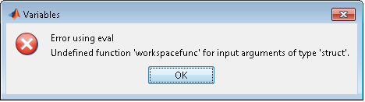

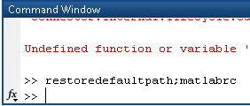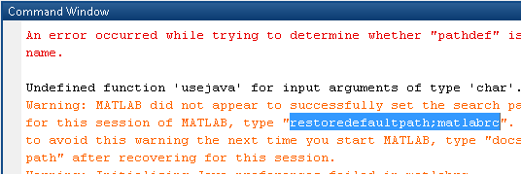

## Open ESR/RIG Errors

You have selected a wrong folder, e.g. gotten ESR/RIG mixed up. Check all data files are in ONE folder for ESR and csv files are in subfolders for RIG.

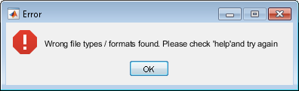

There are csv files present that are not the test data format. Or some columns in the middle are empty or has no variables.

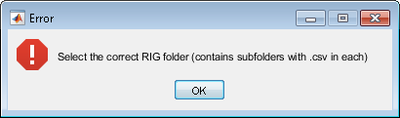

The Rig folder selected has a subfolder with 5 or more csv files. This is uncommon as most only have 2 for that test point.

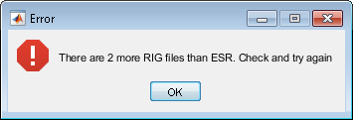

Simply an imbalance in file numbers, remove or merge files in ‘File Order’ or manually correct them in files explorer and reload in the app.

## Loading Bar cannot be closed

If an error occurred leading to the loading bar being stuck and unable to be closed, type in command window *“close all force”.* Note: this will also close the app.

## ‘gettable’ function error

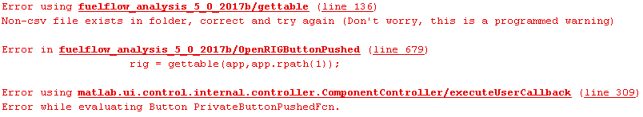

This is if app detects an empty variable in one of the columns, this could happen because a random non test data csv is present or sometimes there are empty columns in the middle.

## Save Summary Errors

If incorrectly re-selected variables, warning will pop up displaying previously selected variables. If impossible to continue due to missing variable in the test point, close the window and options will appear to cancel or skip the test point.

## Variables Missing Error (Calculate Button)

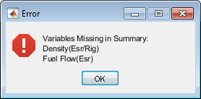The required variables to be used in flow equation are:

Density(Esr/Rig), Outlet Pressure(Esr), Hose End Pressure(Rig), Latch Pressure(Rig), Fuel Flow(Esr), Fuel Flow(Rig), Hose End Pressure(Esr)

Re save summary and include missing variables.



If you are sure the variable is present, go to in appdesigner and edit the required variable. For example for ESR Fuel Flow Rate:



[“FuelFlow”,”Fuel_Flow”] contains strings to search for in app.eavg (ESR), use app.ravg for RIG

[“Mass”,”Limit”] contains strings to exclude variables which may contain “FuelFlow” etc.

## Error in AddChart (Export Flow Data)

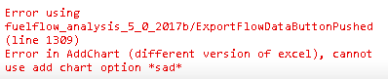VBA commands:

*.AddChart* for Excel 2013 and after

*.AddChart2* for Excel 2012 and before

App tries both, but if neither works, consult <https://docs.microsoft.com/en-gb/office/vba/api/overview/> for how to add chart shape in your excel version.

** For any other errors in the addchart function or export that is VBA related, search in the above link for the latest code (confirmed works with Excel 2016 and 2010) **

## Plot Coupling Loss: Nothing / In Loading Bar

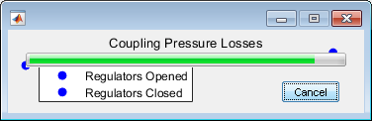This is due to previous error leading to loading bar not able to close. Will have to restart if this is a must (see solution above). Note: this plot is present in summary if chosen to ‘Add graphs to Excel’.

## Connect to the [H] drive first

The memo is located in the H drive, the app will attempt to connect to the H drive using a shortcut link placed in the temp (S) drive and Cody Lau temp(S) drive folder. This will fail if either were removed or moved. If so, connect to the H drive manually then press the memo button again. Full link:

**H:\Admin\External\Memos & TNs\Memos\951 Flow Data Analysis App.docx**

## File In Use, Locked for Editing

If this is straight after the ‘Export Flow Data’ process which added charts, it will sometimes take a few seconds before the background process closes the file. So just wait a few seconds and reopen it.

## Error using fgets

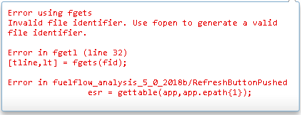Error in my ‘gettable()’ function. Results from corruption in either app.epath or app.rpath (epath in this example). Either app.epath is empty or this entry in app.epath (file path)’s file doesn’t exist anymore, check you have not deleted the file while using this app.

# Flow Transfer Equations and Methods

All the calculations relating fuel transfer are done in:

## 905E, 912E (Imperial)

Phe = Ppo – K1ρQf2 + K2ρ (as described in 912E-ES-002_5_.docx and 905E-SSRD-043_20_.docx)

Where: Phe = Hose End Pressure (psi), Ppo = Pump Outlet Pressure (psi), K1 = Hose Loss Factor, p = Density(lb/gal), K2 = Catenary Gain Factor, Qf = Fuel Flow Rate(USgpm).

Summary Calculations: [variable name in the app in “CalculatedandPlotFlowButtonPushed”]

[y] dP (corrected for catenary) = Ppo – Phe + avg. rho * 9.81 * dH (replace Phe wit Pl to include coupling)

[dP] dP (RCU) = avg. rho * K1 * Q^2

[calPhe] Calculated Phe = Ppo – K1 * rho * Q(esr) + K2 * rho

Kloss = slope / avg. rho (slope of line of best fit through 0 for dP against Q^2)

## 908E, 908EH (SI)

Phe = Ppo – (Khl + Kcl)ρQf2 + Kcgρ (as described in 908EH-ES-003_1_.docx)

Where: Khl = Hose Loss Factor, Kcl = Coupling Loss Factor, Kcg = Catenary Gain Factor.

Different Units: Phe = kPa, Ppo = kPa, p = kg/m^3, Qf = L/s.

## 910 (Imperial) [Has not been tested due to lack of test data]

Phe = Ppo – (CRE*Khl + Kcl)ρQf2 + Kcgρ (as described in RP910E-75-ES-045_9_.docx)

Where: Cre = Reynolds Correction Factor. This coefficient is obtained as follows: rho🡺viscosity🡺Re🡺CRE  Using the



### Rho 🡺 Viscosity (look up table)

|  |  |
| --- | --- |
| **p (Kg/m3)** | **v (m2/s)** |
| ρ ≤ 773 | ν = αρ+β |
| 773 < ρ ≤ 832 | ν =A1ρ5 + A2ρ4 + A3ρ3 + A4ρ2 + A5ρ +A6 |
| ρ > 832 | ν = B1ρ4 + B2ρ3 + B3ρ2 + B4ρ + B5 |

Where:

|  |  |
| --- | --- |
| **Coefficient** | **Value** |
| **α** | 8.59415305976075E-09 |
| **β** | -5.59208021888923E-06 |

|  |  |
| --- | --- |
| **Coefficient** | **Value** |
| **A1** | 2.38402723512495E-15 |
| **A2** | -9.14947972622544E-12 |
| **A3** | 1.40392422313046E-08 |
| **A4** | -1.07659438678346E-05 |
| **A5** | 4.12584245862576E-03 |
| **A6** | -6.32131305709171E-01 |

|  |  |
| --- | --- |
| **Coefficient** | **Value** |
| **B1** | 1.70744624416575E-11 |
| **B2** | -5.74268841367930E-08 |
| **B3** | 7.24368939505538E-05 |
| **B4** | -4.06129135030113E-02 |
| **B5** | 8.53963882581498E+00 |

### Viscosity 🡺 Reynold’s number

 (as described in RP910E-75-ES-045_9_.docx)

Where: D = Hose Internal Diameter, Q = Fuel Flow Rate, A = Hose Cross-sectional Area, ν = Fuel Kinematic Viscosity, KLtoM = 0.001

### Reynold’s number 🡺 Reynolds Correction Factor (Look up table)

|  |  |
| --- | --- |
| **Re** | **CRE** |
| Re ≤ 5078 | CRE = A1Re2 + A2Re + A3 |
| 5078 < Re ≤ 7.5e4 | CRE = B1ReB2 + B3 |
| 7.5e4 < Re ≤ 5e5 | CRE = C1ReC2 + C3 |
| Re > 5e5 | CRE = D1Re3 + D2Re2 + D3Re + D4 |

Where:

|  |  |
| --- | --- |
| **Coefficient** | **Value** |
| **A1** | -4.267201030479049e-09 |
| **A2** | -2.153867836103919e-04 |
| **A3** | 3.112789509388798 |

|  |  |
| --- | --- |
| **Coefficient** | **Value** |
| **B1** | 6.398531531217704e+01 |
| **B2** | -4.592807528896194e-01 |
| **B3** | 7.298284194055338e-01 |

|  |  |
| --- | --- |
| **Coefficient** | **Value** |
| **C1** | 3.207728059299550e+02 |
| **C2** | -6.305019204696392e-01 |
| **C3** | 8.299952643688508e-01 |

|  |  |
| --- | --- |
| **Coefficient** | **Value** |
| **D1** | -2.135027382370963e-20 |
| **D2** | 9.674970001826801e-14 |
| **D3** | -1.590283356135035e-07 |
| **D4** | 9.692671422144649e-01 |

# Functions List (include online references)

## Original:

gettable(app,path) 🡺 returns table for path’s csv file. Removes extra “,” at the end of first line

getcol(app,table,name,xname) 🡺 returns array of items for a variable in table. Variable is found by searching all which contains all in name(string array) and doesn’t contain all in xname (string array)

getlog(app,list,value) 🡺 returns logical array of items in list which exactly match value

rho2c(app,density,flowrate) 🡺 returns Reynol’s Correction Factor using density and flowrate (for 910)

addchart(app,chartname,array,series,xname,yname,title,column) 🡺 adds a single chart to Excel summary with array of column numbers in excel (in pairs of x-y), cell array of series names, xname for x-axis, yname for y-axis, title for chart and location for the chart as column

## Matlab Central File Exchange

natsortfiles 🡺 sorts file names in cell array in natural order

<https://uk.mathworks.com/matlabcentral/fileexchange/47434-natural-order-filename-sort>

natsort 🡺 sorts cell array items in natural order

<https://uk.mathworks.com/matlabcentral/fileexchange/47434-natural-order-filename-sort>

xlcolumn 🡺 converts a number to Excel column letters (e.g. 5 = E, 28 = AB)

<https://uk.mathworks.com/matlabcentral/fileexchange/5942-xlcolumn>

# Version History

All versions are stored in [S:\Cody Lau\Flow Data Analysis App Old Versions], all except 5.0 only work in Matlab 2018.

|  |  |
| --- | --- |
| Version | Changes |
| 1.0 | Interface created, functional for 905 with all ESR and RIG csv files in one folder |
| 2.0 | New open file method (correct), ESR and RIG separated, subfolders for RIG, better summary (char search important variables) |
| 2.1 | Flow equation in SI for 908, checks if excel opened before saving, user input K1 and K2 |
| 3.0 | User select variables to include in summary (still auto selects from char search), accommodates different number of columns, order, spelling between test points |
| 3.1 | Select 905 or 908 which changes equations units, tooltips for all |
| 3.2 | Panels, more tooltips, loading bar for save summary, app.error means can't save summary if different number of files opened in ESR/RIG |
| 3.3 | Fix char search for summary and flow calculation, fix msgbox so always on top in save summary when reselecting new |
| 3.4 | Import summary, separate app.avg into app.eavg and app.ravg meaning flow calculation search is improved, refresh button for listbox change |
| 3.5 | Fix import summary, new export flow calculations to copy of summary, number of variables selected indicator |
| 3.6 | Open files options (blank extensions ESR, all in 1 folder RIG), Add extensions button, more robust |
| 4.0 | Fix open file order using natsort() and renaming . To _ , space to _ and zero to 0, added lookup coefficients for RE in 910 |
| 4.1 | loading bar for open files, fix natfort, app.file redundant, File Order button |
| 4.2 | Fix natsort to only rename copy (not actual files so much faster), refresh button not fixed |
| 4.3 | Refresh fixed, new app.matrix2 (no catenations), incorrect reorder buttons (swap 2, insert above, reorder all) |
| 5.0 | Add charts in excel format to summary, loading bar for export, fix reorder buttons using getlog(), fix calPhe to use rho not avgrho, Remove and Merge button, final version so created verison for 2017 Matlab, small changes in 2017 |